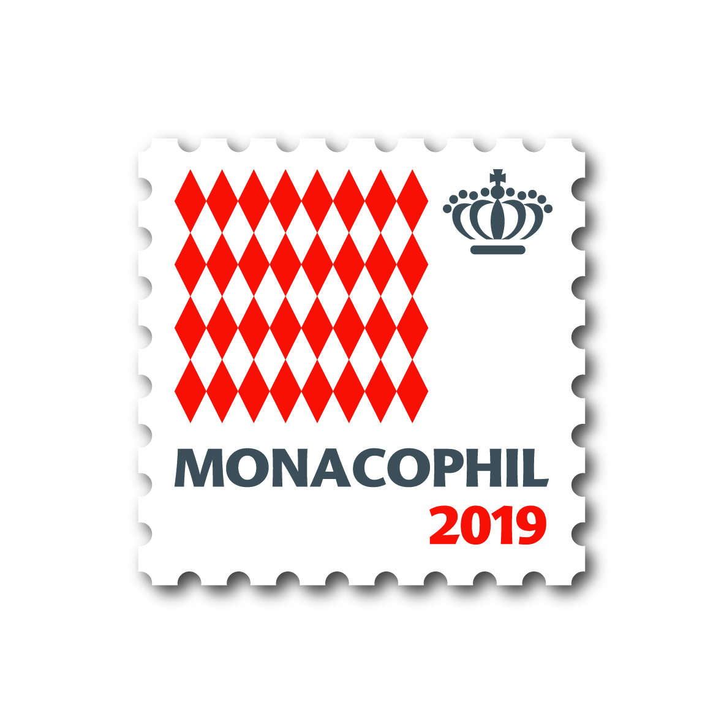 MONACOPHIL 2019

VIP REPLY FORM FOR THE ACTIVITIES page 1/2

Name: ……………………………………………………………………………

Please do complete and return this form by e-mail to : info@maselis.be , by fax to + 32 51 22 69 50
or by mail to Patrick Maselis Kaaistraat, 19 B-8800 Roeselare - Belgium
before June 1st 2019

- I shall attend the Welcome Cocktail on November 27th

NO YES Number of participants, including yourself:
If the guest is not your husband or wife, name of guest:……………………………….

- I shall attend the Christophe Gaertner Award Ceremony on November 28th

NO YES Number of participants, including yourself:
If the guest is not your husband or wife, name of guest:……………………………….

- I shall attend the Gala dinner on November 28th

NO YES Number of participants, including yourself:
If the guest is not your husband or wife, name of guest:……………………………….

- I shall attend the Köhler-Corinphila „Editions d’Or“ presentation on November 29th

NO YES Number of participants, including yourself:
If the guest is not your husband or wife, name of guest:……………………………….

- I shall attend the AIJP book presentations on November 29th

NO YES Number of participants, including yourself:
If the guest is not your husband or wife, name of guest:……………………………….

- I shall attend the James Van der Linden book presentation and Delcampe cocktail on November 29th

NO YES Number of participants, including yourself:
If the guest is not your husband or wife, name of guest:……………………………….

- I shall attend the General Meeting of the AEP on November 30th (AEP Members only)

NO YES

- I shall attend the lunch after the General Meeting of the AEP on November 30th

NO YES Number of participants including yourself:
If the guest is not your husband or wife, name of guest: ………………………………….

- I shall attend the Closing dinner on November 30th

NO YES Number of participants, including yourself:
If the guest is not your husband or wife, name of guest:……………………………….

MONACOPHIL 2019

VIP REPLY FORM FOR THE ACTIVITIES page 2/2

Name: ……………………………………………………………………………

Please do complete and return this form by e-mail to : info@maselis.be , by fax to + 32 51 22 69 50
or by mail to Patrick Maselis Kaaistraat, 19 B-8800 Roeselare - Belgium
before June 1st 2019

- I shall attend the General Meeting of the Club de Monte Carlo on December 1st (CMC Members only)

NO YES

- I shall attend the lunch after the General Meeting of the Club de Monte-Carlo on December 1st (CMC Members only)

NO YES Number of participants including yourself:
If the guest is not your husband or wife, name of guest: ………………………………….

SIGNATURE: ……………………… DATE: ……………………………………

