The Grand Prix Club Book – Curriculum Vitae (CVs) of Grand Prix Club Members 2001 – 2018

Grand Prix Awards Spain; Rates during the Isabel II Reign. 1850-1865
Grand Prix d´Honneur. – BRASILIANA 2017

Finland; 1st Issue and Rouletted. 1856-1874.
Grand Prix d´Honneur – PORTUGAL 2010

Brazil Bulls Eye's; First Stamps of America 1843-1854
World Stamp Championship. ISRAEL 2008
Grand Prix International – SPAIN 2006 (Málaga).

Spain; Kingdom of Queen Isabel II, 1850-1865.
Grand Prix National – SPAIN 2000 (MADRID)

Airmail Postmarks and cancellations related to Spain. 1871-1950
Grand Prix National – AVIACIÓN Y ESPACIO 1996 (SEVILLE)

Argentina; Classic Issues. 1856-1867
Grand Prix International – GRANADA 1992

Spain; Kingdom of Queen Isabel II. 1850 – 54
Grand Prix International – PHILANIPPON 1991

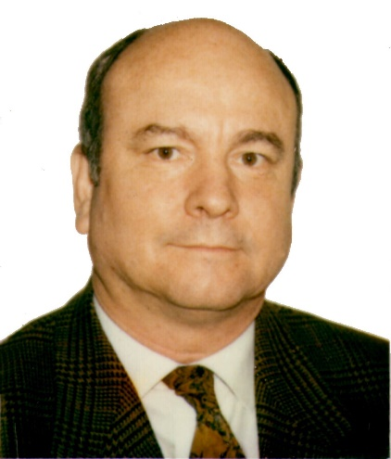

PERSONAL DATA

First Name Luis
Last Name Alemany Indarte
Born 26 February 1940
Nationality Spanish

Born in Madrid in 1940, Mr. Luis Alemany Indarte began collecting stamps in his childhood. He has specialised in Spanish First Issues and Postal History, but is also interested in all topics related to Spain, like “Incoming Mail”, “Mail through Cuba”, “Ship mail”, “Registered mail” or “Postal Agreements”. He also collects “Airmail”, “Colonies in Africa”, “Civil War”, “Fiscal stamps” and “Vignettes”, owning around 100 collections. From 1990 Mr Alemany started to collect international stamps, such as “Classical Argentina “or “Nicaragua”. In 2000 he began with “Brazilian Bulls Eyes 1843“, “Classical Finland “, “Brazil; Don Pedro II “, and “Netherlands first Issues “.

Mr Alemany has been Vice-President of the GPC, President of the Madrid Philatelic Society, Vice-President of the Royal Hispanic Academy of Philately and Postal History, member of the National Philatelic Commission for new Spanish Stamps Issue, and President of the Commissions Against Forgeries, Traditional and Fiscal Stamps of the Spanish Philatelic Society.

He is International Jury on Traditional and Postal History, and has organised many national and international exhibitions. He has given numerous lectures and published several philately articles, books and catalogues on many and varied subjects.

Mr Alemany is a very active exhibitor, receiving more than 120 Large Gold medals, 40 of them in FIP competitions, and achieving more than 45 Grand Prix’s Awards, 8 of them in FIP exhibitions.

Doctor in Architecture, Mr Alemany specialized in urbanism. During the 1970s he designed Madrid`s Central Business District, building as an architect several skyscrapers and shopping centres. During the 1980s he planned one of the largest extensions of the city (15.000 homes) and then built many of these in the 1990s. He is also well known for an expansion of Real Madrid Football Club’s famous Santiago Bernabéu Stadium (designed by his father in the 1940s) carried out for the FIFA soccer World Cup “Spain 1982”.

He loves opera and classical music, and has travelled widely. He credits his wife, Marisa, for her tremendous understanding whilst he pursued his hobby. They have three sons, and four grandchildren.

The Grand Prix Club Book – Curriculum Vitae (CVs) of Grand Prix Club Members 2001 – 2018

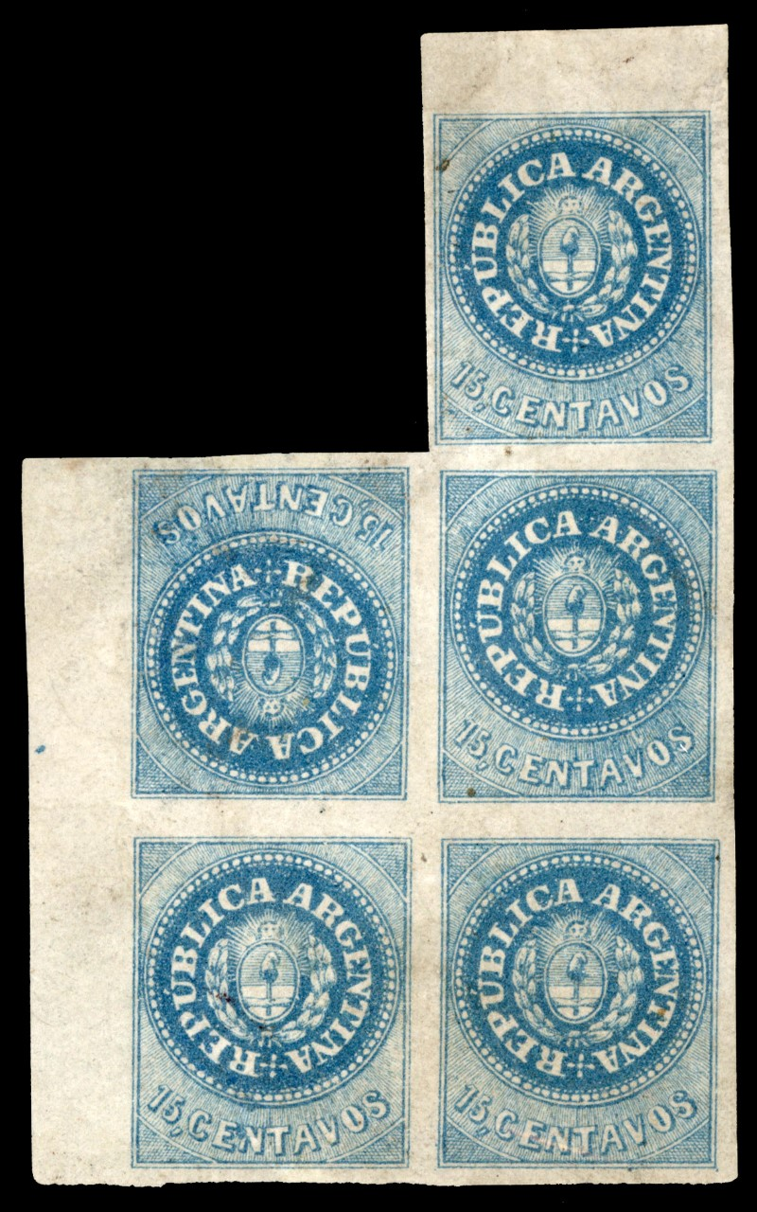

ARGENTINA, THE 1862 ESCUDITOS ISSUE.
15 Centavos block of 5, left and upper margin sheet with a
TETE BECHE Stamp on the second line, first position.

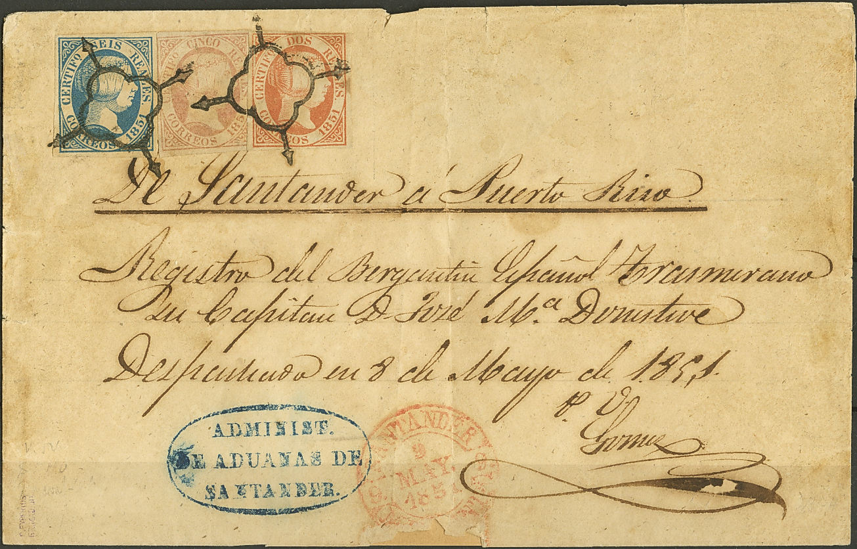

SPAIN, THE ONLY KNOWN SHIPMENT REGISTERED COVER TO PUERTO RICO.
2 reals, 5 reals and 6 reals 1851 issue used on cover from Santander to Puerto Rico.
Franked at 13 reals for a weight of 12-13 Adarmes. UNIQUE.

The Grand Prix Club Book – Curriculum Vitae (CVs) of Grand Prix Club Members 2001 – 2018

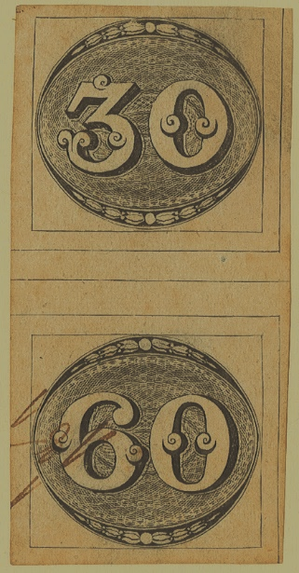

BRASIL, 1843 BULL EYES. THE XIPHOPAGUS PAIR.
30 reis upper pane and 60 Reis intermediate pane, forming a gutter pair.
UNIQUE.

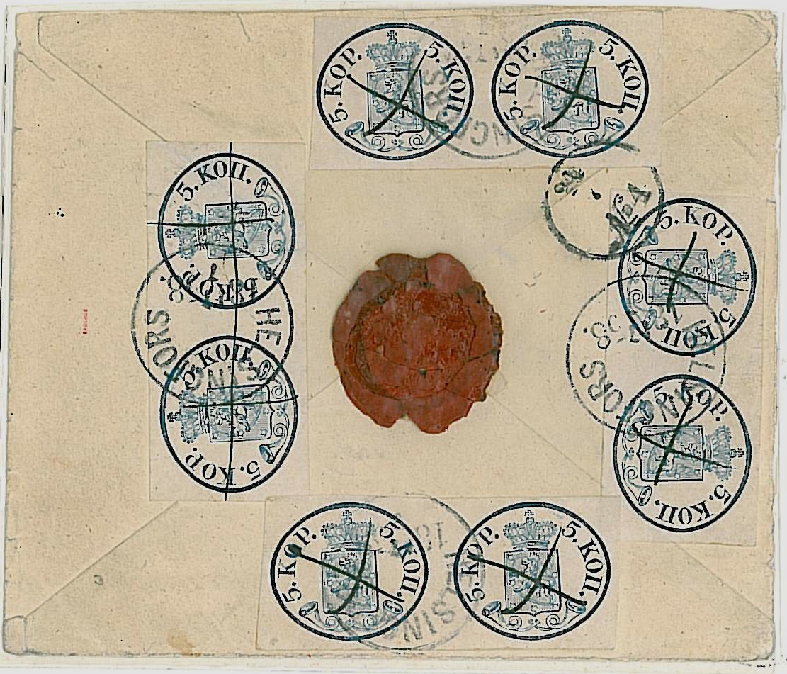

FINLAND. THE 1858 FABERGÉ COVER.
5 Kopeck blue Large Pearls ordinary paper IIb. Four horizontal pairs.
The largest Franking of the Finland First Issue.

