STAMP ACTIVE NETWORK
The Stamp Active Network was recently awarded the FEPA Certificate of Appreciation for outstanding activities for the promotion of philately.
But what is it all about?
Stamp Active Network, formerly known as the National Youth Stamp Group (and, before that, The Melville Committee, was first established by the Philatelic Congress of Great Britain in 1952), is the UK’s leading organisation promoting stamp collecting among young people in Great Britain. It aims to support all young collectors and junior club leaders throughout the UK. It is the only nationwide organisation dedicated to encouraging and developing youth philately.

The “Stamp Active” programme was, initially, a resource programme supported by an activity pack, launched by John Davies at Stamp World London ’90 in May 1990. Since then, its activity has been fully integrated into the other youth philately initiatives taking place in Great Britain, detailed below:

STAMP ACTIVE WEBSITE sponsored by ABPS
www.stampactive.co.uk for the latest information and activities about youth philately in the UK.
Sections include: Home Page
About Us
News
Competitions
Stamp Den
Stamps in Schools
Contact Us

The website was awarded a Large Gold Medal and “Best in Class” at Italia 2018.

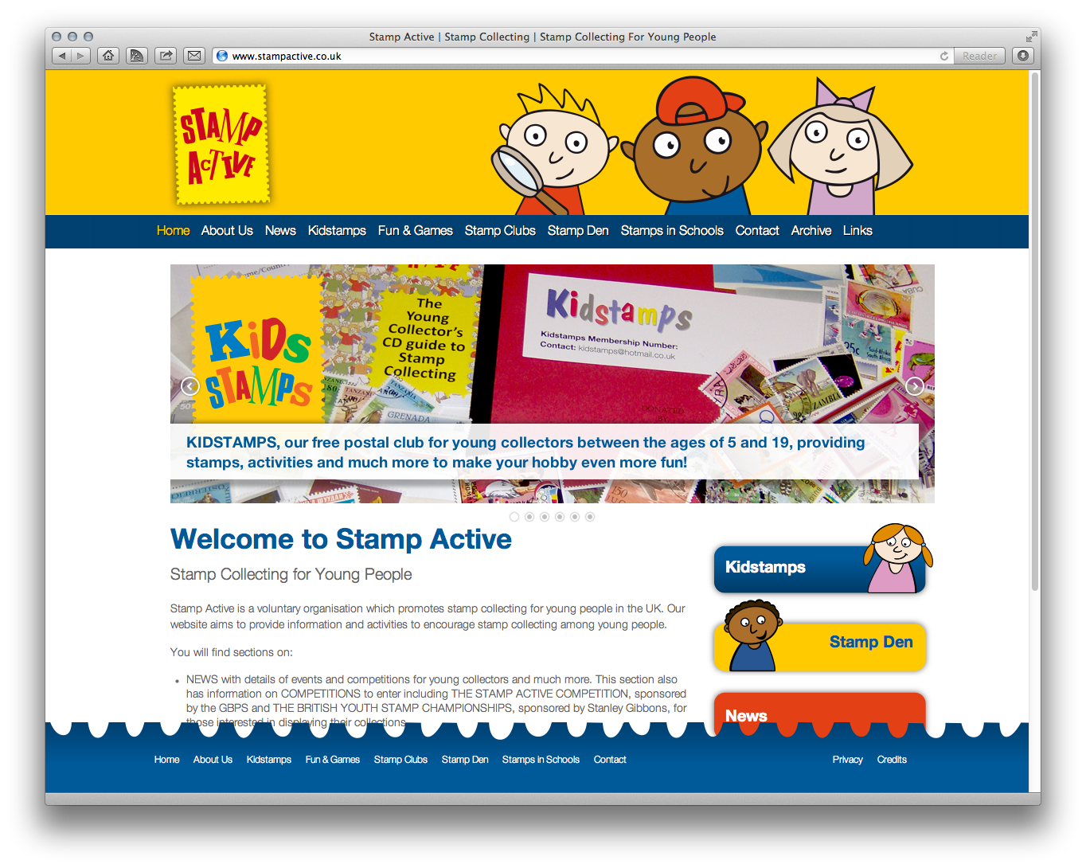

KIDS ZONE (Exhibitions and Events) sponsored by the Philatelic Traders’ Society
Kids Corner is a major feature at national exhibitions such as Spring and Autumn Stampex and ABPS regional events, providing fun stamp-related activities. We will also support the UK international exhibitions, subject to sponsorship.
The Kids Zone provides free goodie bags, activity sheets on different themes each time, a free children’s points auction (Saturday only). There is also a Lucky Dip, Spin a Prize and Guess the number of stamps in the Jar as fun activities.
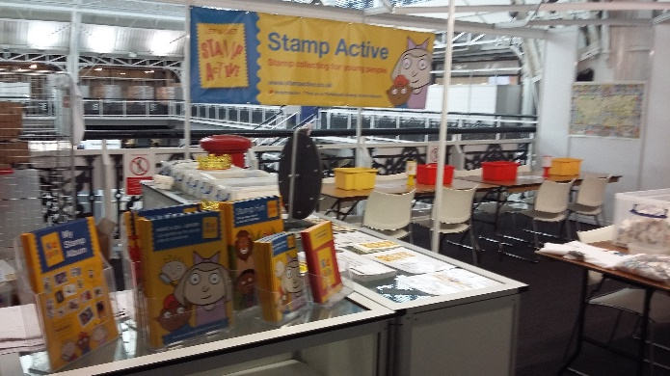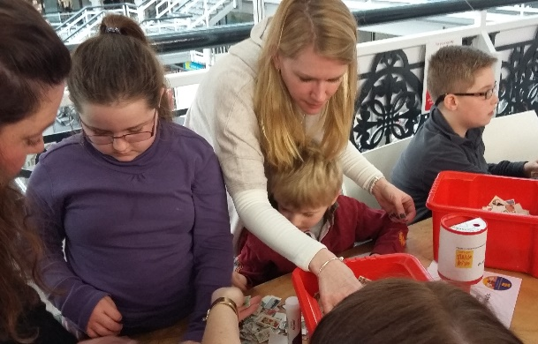
KIDSTAMPS
A postal stamp club which provides free stamps and activities for young collectors between the ages of 4 and 19. We have sent out starter packs to over 2000 individual children and have an active membership of up to 300 children at any one time, sending out packets of stamps and FDCs four times each year.

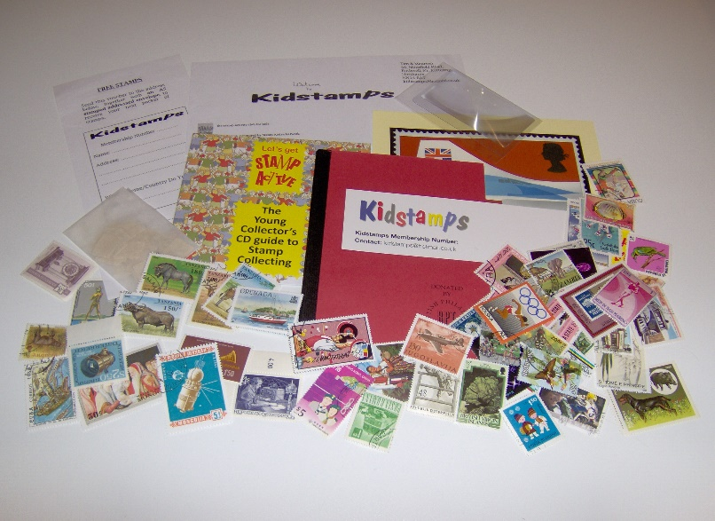

STAMP ACTIVITY BOOKS
We provide educational booklets for young collectors free of charge.
These have included Stamp Fun, Sport on Stamps, All at Sea, Brilliant Britain, All Creatures Great and Small and Transport on Stamps.
Copies can also be downloaded from the Stamp Active website.

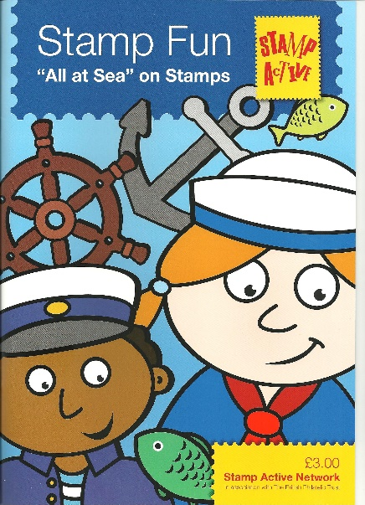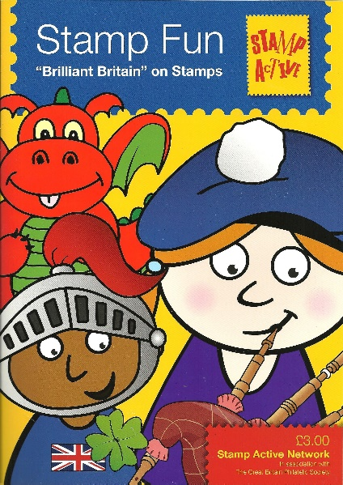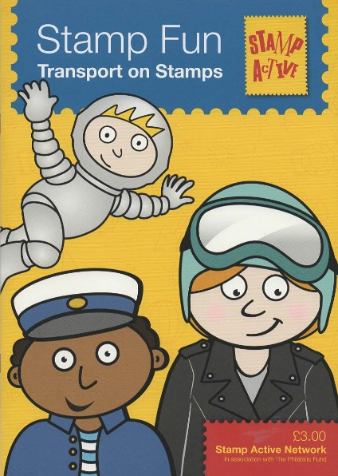

Over 3000 of each of the activity books have been distributed to children via school stamp clubs and events in recent years.

COMPETITIONS
There are three national youth competitions at the moment, held annually.
The Stamp Active Competition is held at both Spring and Autumn Stampex.
Detailed information is on the Stamp Active website.

One Page Competition (My Favourite Things)
sponsored by Stanley Gibbons
This is held at Autumn Stampex and is the simplest of the competitions for children to enter.

Stamp Active Competition
sponsored by Stanley Gibbons and the Great Britain Philatelic Society
This is held at both Spring and Autumn Stampex and is the entry level for the new youth exhibitor. We accept from 4 to 24 pages.

The British Youth Stamp Championships, sponsored by Stanley Gibbons
This is the premier UK competition, requiring a minimum of 16 pages and awards in this qualify young exhibitors for international competition if they meet the required standard.

A short guide to competitions has been produced for youngsters, “Have a Go, Show!”
This can also be downloaded from the Stamp Active website.

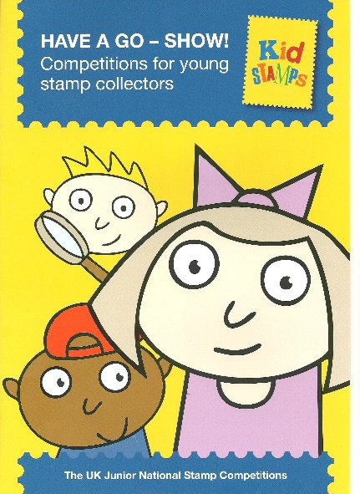
AWARDS
We give these to recognise the achievements of organisers and young collectors. The two annual awards are:
The Anne Dummer Trophy for “Young Collector of the Year” sponsored by Midpex. Nominations are requested each year.
The Bill Hart Award for outstanding service to youth philately, selected by the Committee. Both receive a gift and/or a trophy or framed certificate, usually at Autumn Stampex.

STARTER PACKS for Junior Club Organisers, sponsored by Stanley Gibbons
We offer Help and support for the organisers of school and junior stamp clubs in terms of a pack of materials, stock books, tweezers and magnifying glasses, hinges, stamps etc.
Around 100 packs have been distributed to club organisers in recent years.
There is an application form on the website.

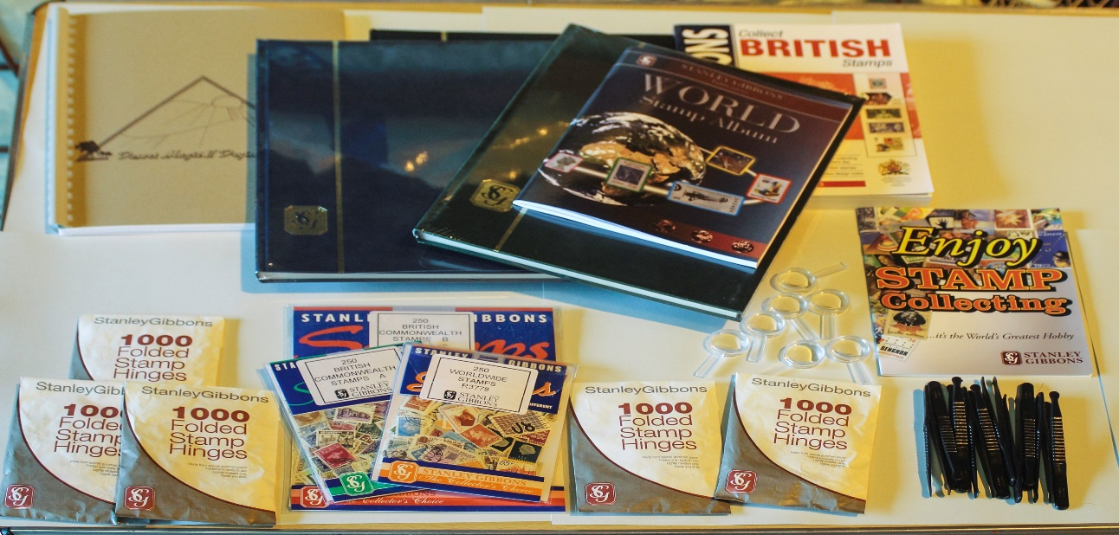

FUND RAISING
We require a regular flow of funds to finance our activities and specific sponsorship for one off projects. A Dealer Patron scheme provides this at the moment. Currently, the financial position is strong.

PROMOTIONAL ACTIVITY & NEWSLETTER
A Newsletter is prepared three times each year and is circulated by email, usually at the beginning of each school term to everyone on our database.
Press Releases are circulated through our database of clubs, helpers etc.

We also support Stamps in Schools, which is an independent project run in association with the Postal Museum by ERENE GRIEVE, that provides an introduction to the hobby for schools with talks, displays and hands-on-experience.
Details are also on the Stamp Active website
www.stampactive.co.uk

