When evening came…“Let us go over to the other side…” (Mark, 4,35)

After 55 wonderful years together, the great and exciting joie de vivre of
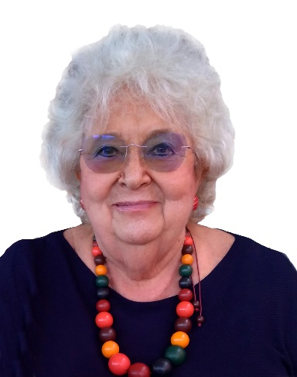
Daniela Morolli
(24.5.1945- 16.10.2020)
faded out after long suffering endured with that positive spirit that made us love her.
Her husband Giancarlo announces it with deep love and endless gratitude
but also with great bitterness for not being allowed to assist her in this last stage,
together with his brother Mario with Simona and their daughters Beatrice and Eleonora,
and the cousins Bianchini, Morolli, Penzo Giacca, Pieri, Salvi and Schneider.
She is accompanied by the affection and gratitude of the several hundreds of people
who learned our language from her, in 35 years of enthusiastic voluntary work,
first in Pullach (Bavaria) and then in San Felice.
The latest news on upcoming restrictive measures of public events
do not allow details on funerals at the moment.
The corpse will still be buried in the family tomb.
the monumental and civil cemetery of the city of Rimini.
REQUIESCAT IN PACE

