Could we include Two and Three Frame exhibits in international exhibitions?
Rainer Fuchs FRPSL makes a case for reviewing the FIP / FEPA regulations.
For some time, one-frame exhibits of 16 sheets have been accepted in international exhibitions and much has been written about the art of constructing them. A key point is that the subject should be sufficiently compact to enable it to be covered comprehensively in one frame. Indeed, it should not be possible to extend the scope of a good one-frame subject to five frames.
I would like to draw attention to the fact that there are some subjects which are too large to cover fully in a one-frame exhibit but are too small for five frames. They would fit neatly into two or three frames, but current regulations restrict exhibits larger than one frame to five or eight frames. Consequently, two or three frame exhibits cannot be entered for FIP or FEPA exhibitions, although they are often accepted at Nationals.
As an example of the difficulty this restriction places on exhibitors, I refer to my exhibit on Iraq Railway Post Stamps 1928 - ca.1942. The material on this subject is so rare that my two-frame exhibit contains about 45% of what is known world-wide. I have shown this exhibit in Germany up to National level (with 3 frames / 12 sheets each) but internationally I cannot show it in competition because it is not large enough. Hence, I have only been able to show it out of competition - in 2 frames / 16 sheets each at STOCKHOLMIA 2019 and at the Virtual Stamp Show 2020 of the American Philatelic Society, held from 17-22 August 2020, where the virtual audience voted it as the “Multi-Frame Exhibit I Would Most Like To Own”. I conclude from this experience that visitors would be interested in seeing it and similar smaller-sized exhibits at live stamp shows.
At recent virtual exhibitions the strict rules on exhibit sizes have been relaxed somewhat and my proposal is to extend this relaxation to live exhibitions. This would reflect changes of approach to collecting. Many collectors now tend to study smaller areas, often in great detail, but are unable to exhibit competitively at FEPA or FIP shows. Smaller-sized exhibits would also bring more variety to competitions and, with a lower cost of entering, they would encourage more exhibitors to take part. For these reasons I believe that the regulations should be modified to permit two or three frame exhibits to compete on a similar basis to what is already in place for one-frame exhibits and I would like to invite a discussion of this proposal by FIP and FEPA.
Thumbnails of my exhibit, which can best be described as a Traditional exhibit with a strong Postal History section, are shown below. It can be viewed in full size at the online exhibition site of the German Philatelic Federation (BDPh): https://www. exponate-online.de/e_exponat.asp?a=1&e=140
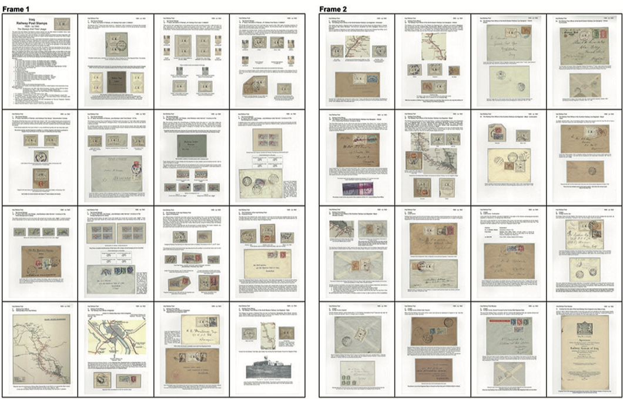
FEPA NEWS January 2021 Page 51

