WE WILL NEVER FORGET YOU

STAMP EXHIBITION FOR COVID-19, DOCTORS and NATIONAL DOCTOR’S DAY

Healthcare workers especially doctors and nurses have been on the front lines of the global effort to care for patients with COVID-19 for over a year, while putting themselves at risk for infection. More than 380 Turkish doctor have died in the COVID-19 pandemic since March 2020.

The stamp Exhibition with Turkish PTT patronage and collaboration with TFDF (Turkish Philatelic Federation) and İstanbul University İstanbul Faculty of Medicine was held on between 11th and 14th of March 2021, at İstanbul Faculty of Medicine Campus hall. The exhibit was in the memory of National Doctor’s day of 14 March and the first time Covid-19 disease recorded in Turkey on 11th of March. Two different first day covers and a special first day stamp were used. The importance of the exhibition was that all exhibitors were philatelist medical doctors. In the memory of the deceased physicians during the pandemic period, special stamps not valid for postage printed by the Faculty and at same time personalised stamps issued.
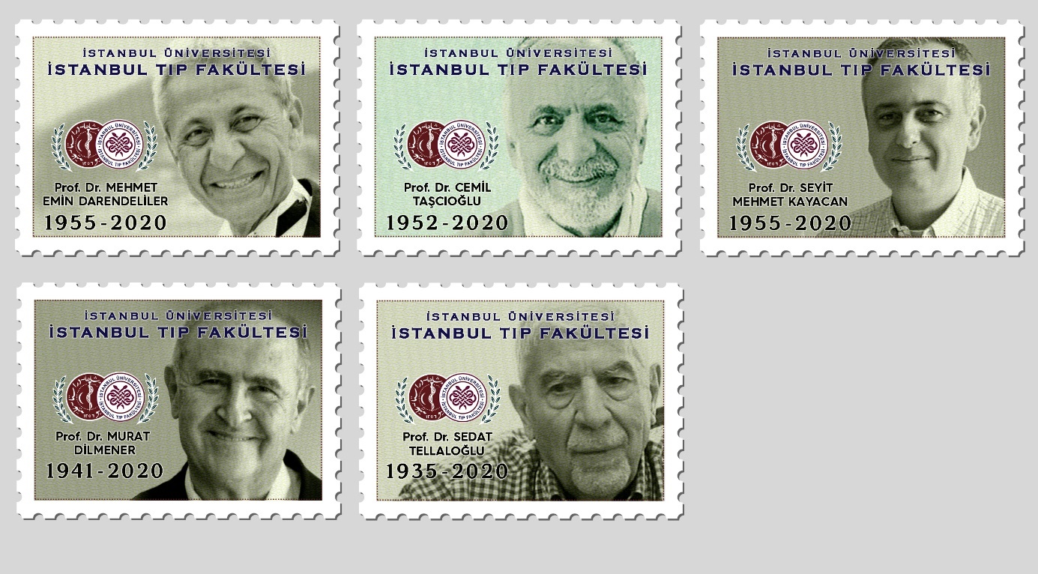
Above stamps printed by the Istanbul Medical Faculty for the memory of some of the deceased physians.

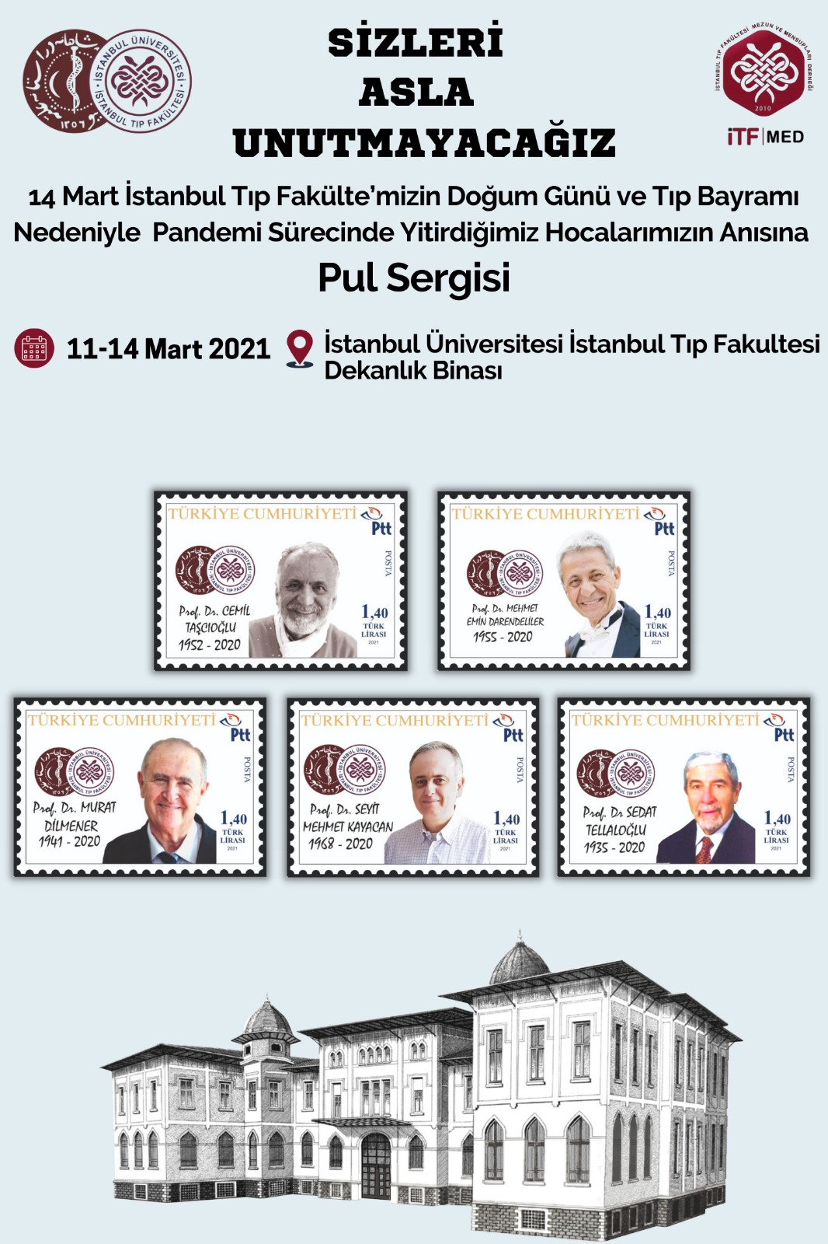
Stamp Exhibition Poster: İstanbul Faculty of Medicine Building and personalised stamps issued for the deceased physicians during the pandemic period titled WE WILL NEVER FORGET YOU.
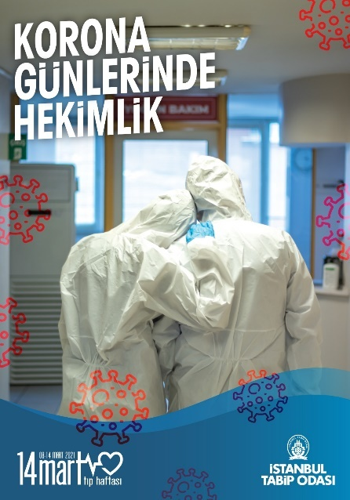
Doctors in corona days
(İstanbul Medical Association’s stamp)

March the 14 is also a very meaningful day for the İstanbul Faculty of Medicine. On that day students of the Istanbul Faculty of Medicine (currently IU Istanbul Faculty of Medicine) took part in the national resistance and the revolt against the Entente States that occupied Istanbul (1919-1922). Today it has been celebrated as National Medicine Day

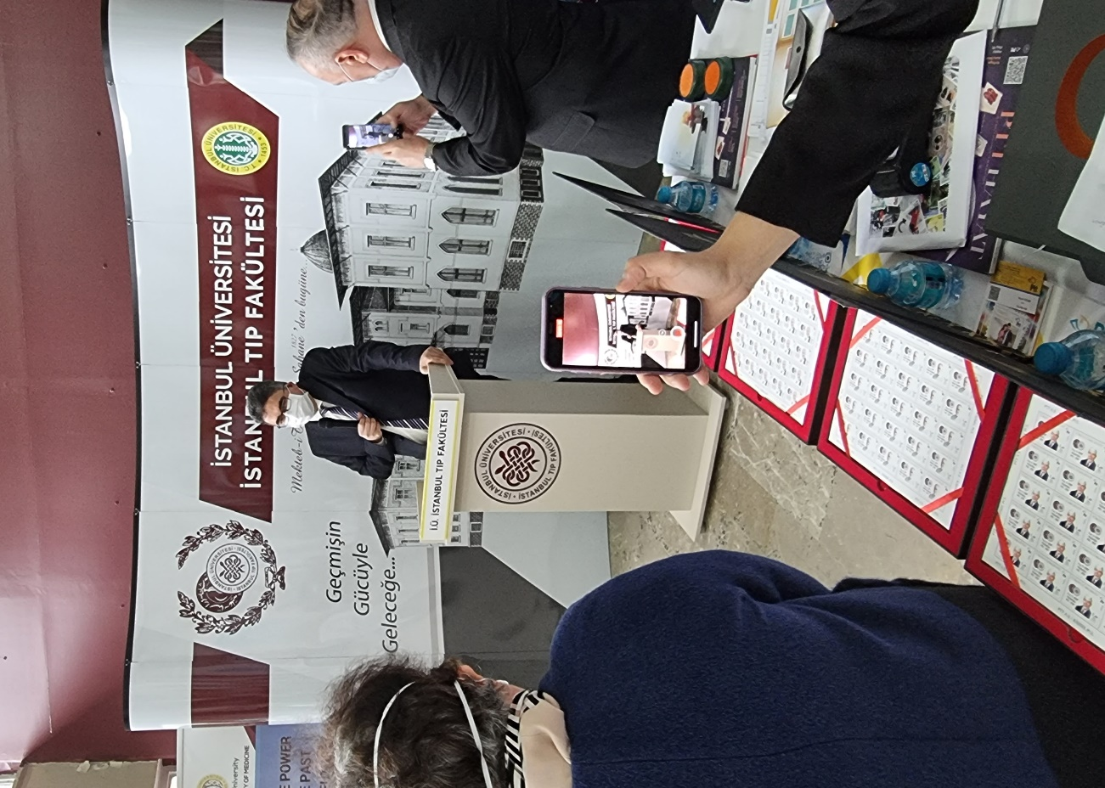
The Exhibition opened by the İstanbul University Faculty of Medicine Dean Prof.Dr.Tufan Tükek.

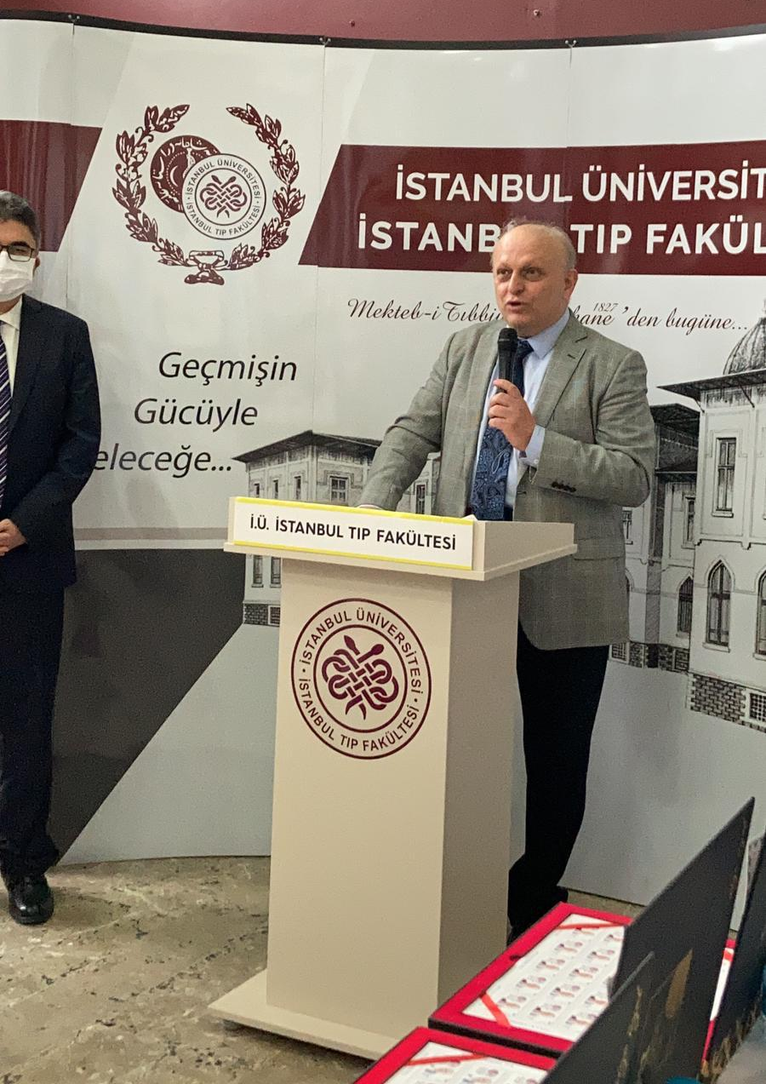
Dr.Atadan TUNACI Board member of TFDF (Turkish Philatelic Federation) and Medical doctor at Istanbul University.

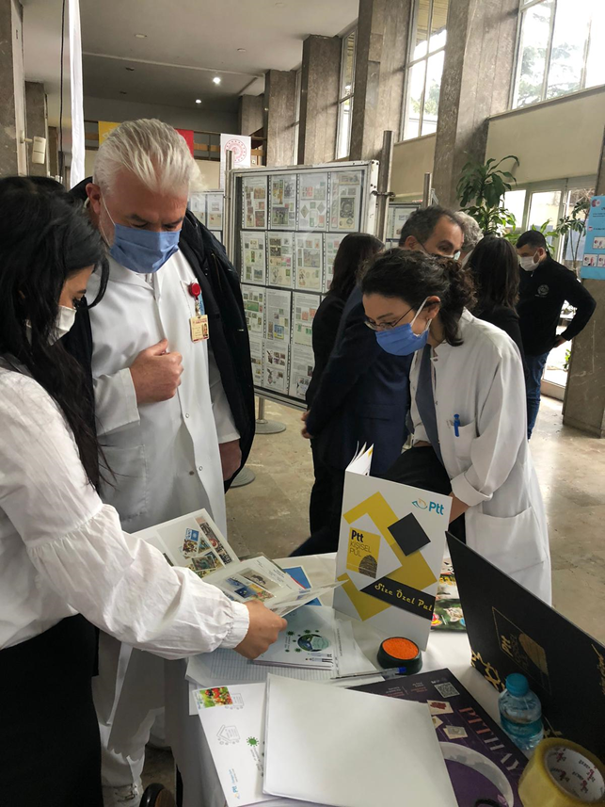
Views from the exhibition
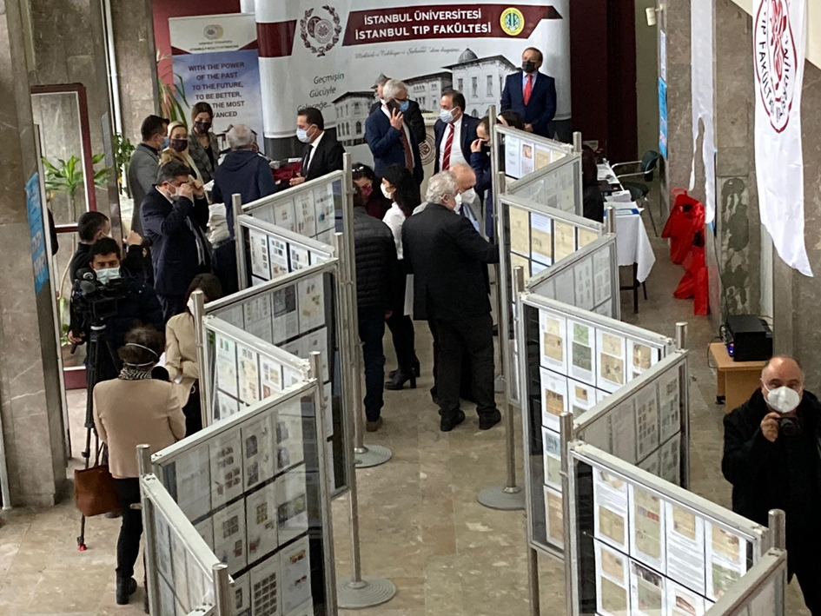
Exhibition Hall

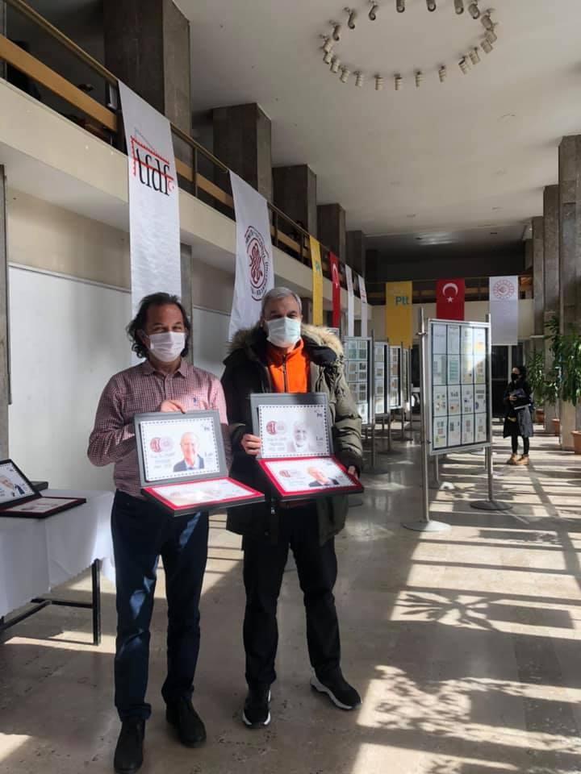
Doctors at Stamp Exhibition
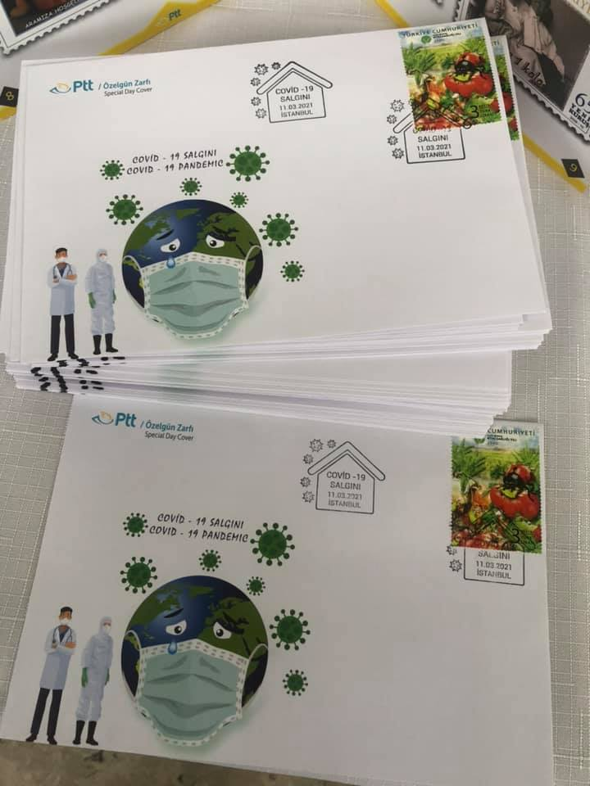
First Day Covers
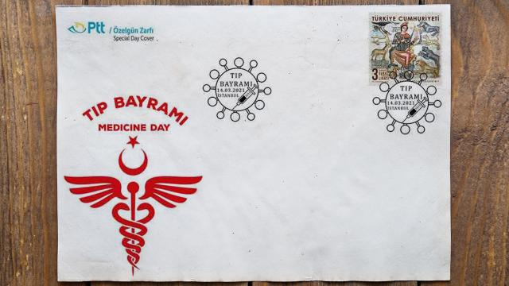
National Doctor’s Day commemorative envelope

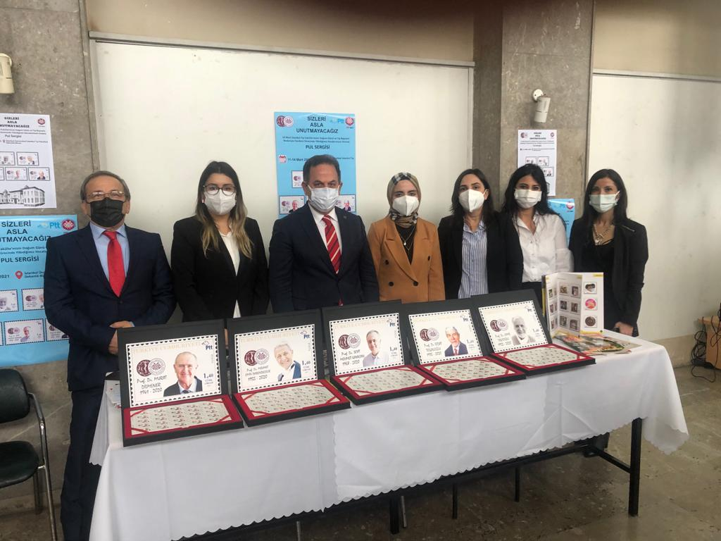
Turkish PTT and Chief Manager of Postal Department
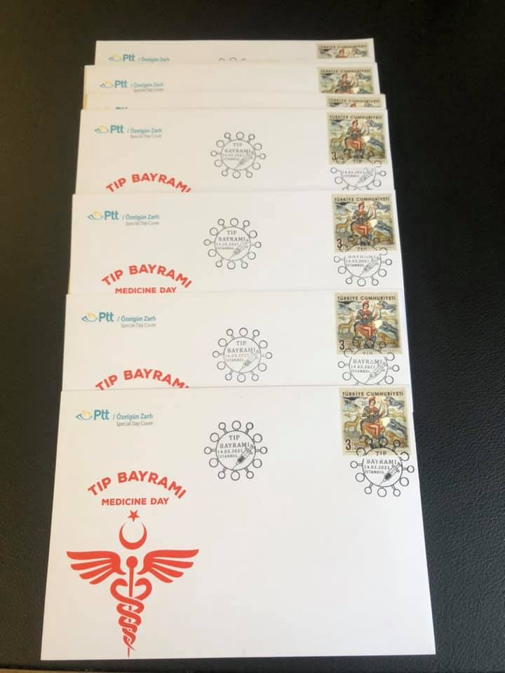

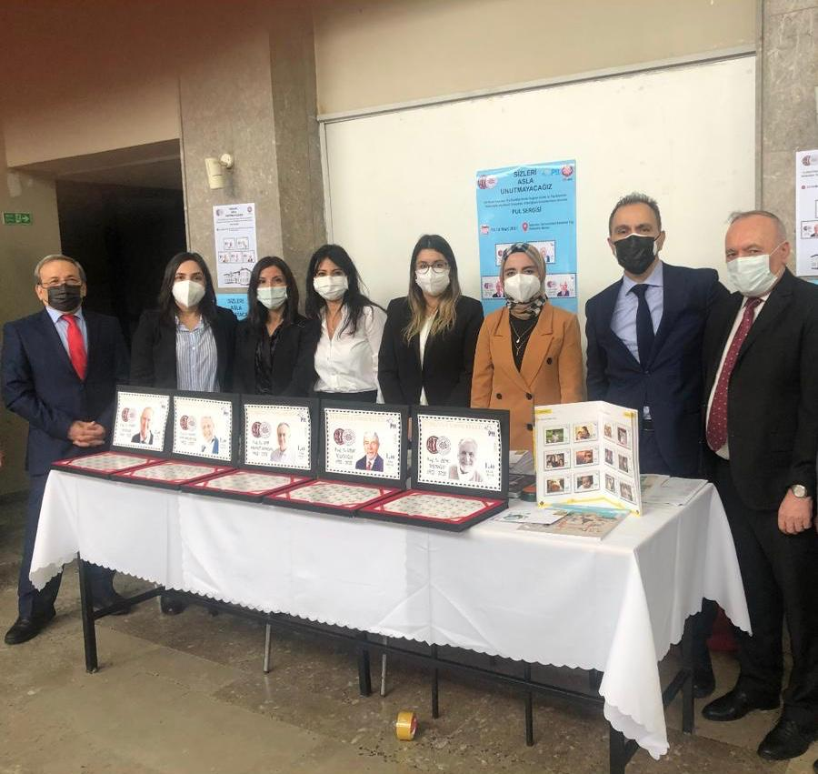
Turkish PTT directors and Chief Manager of Postal Department

