DesetoOkno KRANJ 2021

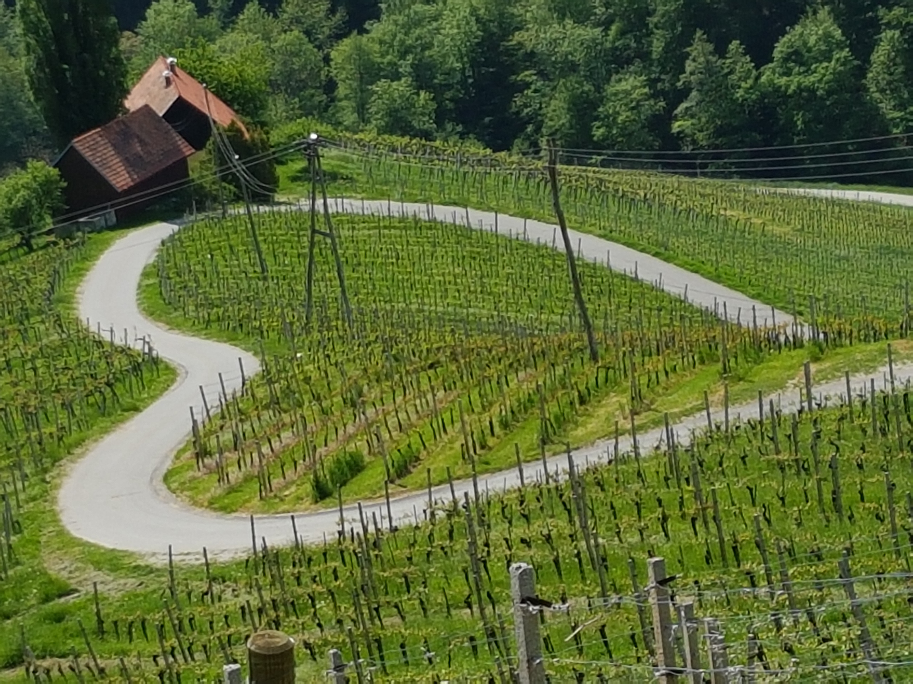

VIRTUAL ONE-FRAME PHILATELIC EXHIBITION
SEPTEMBER 9–18, 2021

Individual Regulations (IREX)
for the biennial One-frame Philatelic Exhibition with International Participation DesetoOkno Kranj 2021

- Name, Aims and Organizer

The virtual philatelic biennial one-frame international exhibition DesetoOkno Kranj 2021 is organized by the Slovenian Philatelic Association (Filatelistična zveza Slovenije - FZS) and Gorenjski muzej in Kranj, in order to support this competitive way of exhibiting. It is open to exhibitors from all countries whose National Federation is a FEPA member.

- Venue and Date

The venue of the exhibition DesetoOkno will be Gorenjski muzej in Kranj, Glavni trg 2. It will be held from Thursday September 9 to Saturday September 18, 2019.

- Principles and Regulations

DesetoOkno Kranj 2021 will be a virtual competitive exhibition of Rank 1. Exhibits should be prepared in accordance with the General and Special Regulations of the FIP for the Evaluation of Competitive Exhibits at FIP Exhibitions (GREV and SREVs), and these Individual Regulations for the One-frame Philatelic Exhibition with Continental Participation DesetoOkno Kranj 2021.

- Exhibition Classes

A Non-Competitive Class

B Competitive Classes
B 1 Traditional Philately
B 2 Postal History
B 3 Postal Stationery
B 4 Thematic Philately
B 5 Maximaphily
B 6 Revenues
B 7 Youth A class
B 8 Modern Philately
B 9 Picture Postcards

Exhibits in all Competitive Classes can be also of Open-Philately type.

- Conditions of participation

Participation in the non-competitive part of the exhibition is subjected to a special invitation at the discretion of the Organizing Committee. In the competitive part the participation is open to all collectors who are members of Philatelic Societies affiliated to the Slovenian Philatelic Association and all other National federations members of FEPA. Exhibits must have obtained on national and related rank exhibitions at least 70 points, new exhibits must be properly justified by the respective National Commissioner.

The entry form can be found at the FZS website: www.fzs.si. Entry Forms must be received by either the Organizing Committee of the DesetoOkno Kranj 2021 or the Commissioner General no later than June 30, 2021. Confirmation of acceptance will be sent out within July 15, 2021. Each collector can participate in the competitive classes with no more than two one-frame exhibits.

Sheet Size:
1) 210 x 297 mm (A4) and/ or
2) 420 x 297 mm (A3).

All exhibit scans must be in JPEG format with 300 dpi quality. No other format or quality will be accepted. In the case of a sheet size of 210 x 297 mm (A4), the file size per page should not exceed 1 MB. In case of sheet size 420 x 297 mm (A3), the file size per page should not exceed 2 MB. The file name corresponds to the numbering of the exhibit list, as follows:

One-frame exhibit 210 X 297 mm (A4): numbering 1-16
One-frame exhibit 420 x 297 mm (A3): numbering 1-8

Each page should be named according to lastname_page.jpg as a filename. If the author has more than one exhibit the filename should be in the format lastname_exhibit_page.jpg

The text of the exhibits can be in one of the FIP languages or in Slovenian.

The Organizing Committee has the right to reject any exhibit without giving reasons for the rejection.

- Obligations and Rights of Exhibitors

The frame fee for all classes is 10 € per exhibit.

Each exhibitor will be entitled to the corresponding diploma.

- Awards

The Jury, appointed by the Executive Committee of FZS, is in principle formed by international (FIP, FEPA) jurors. The exhibits will be evaluated according to the rules adopted at exhibitions under FEPA or FIP patronage.

The Jury can allocate the following awards, appropriate to a Rank 1 exhibition:

- Diploma equivalent to gold medal for 85 to 100 points
- Diploma equivalent to large vermeil medal for 80 to 84 points
- Diploma equivalent to vermeil medal for 75 to 79 points
- Diploma equivalent to large silver medal for 70 to 74 points
- Diploma equivalent to silver medal for 65 to 69 points
- Diploma equivalent to silver bronze medal for 60 to 64 points
- Diploma equivalent to bronze medal for 55 to 59 points
- Diploma of participation for less than 55 points.

The Jury can also allocate the following prizes:

• Grand Prix of the exhibition
• Special Prize
• Special Recognition

The decisions of the Jury are final.

The results will be published on the website of the exhibition on September 18th, 2021, and the Organizing Committee of the exhibition will inform each candidate by e-mail.

8. Submission of the scanned exhibits

The exhibitor is obliged to submit the exhibit in the required jpg format and in the required 300 dpi quality using Wetransfer. Please visit the web page https://wetransfer.com. Drag and drop your files to the web page at “Add your files”. Enter the given email of the Commissioner general (peter.kramar@fe.uni-lj.si), your email and write a message. The message should consist of your name, exhibit title and the competition class. The confirmation of receipt will be sent after the download of your files.

No editing/alteration/modification of the scanned items in any manner will be allowed or accepted.

The deadline to send your scanned exhibit is August 31, 2021.

8. Availability of the exhibits for the public

The online format of the exhibition will be available via the internet (www.fzs.si) and in that sense the organizer is not responsible for copying, duplicating or further use of the scanned pages of the exhibition or any part of it.

The organizer – FZS (Slovenian Philatelic Association) - will save all participating exhibits in the archives of its website, if the exhibitor agrees with that.

9. Supplementary Regulations

The Organizing Committee of DesetoOkno Kranj 2021 has the right to make changes to these Special Regulations, if deemed necessary. The decisions of the Organizing Committee are final.

10. Addresses

Organizing Committee Commissioner General

Igor Pirc Peter Kramar
Ptujska 23 Mošnje 6e
1000 Ljubljana 4240 Radovljica
Slovenia Slovenia
ipirc711@gmail.com peter.kramar@fe.uni-lj.si

Ljubljana/Kranj, 12. 4. 2021

