GIBRALTAR CRYPTOCURRENCY STAMP

Her Majesty’s Government of Gibraltar and Gibraltar Philatelic Bureau Limited have produced an innovative stamp that celebrates cryptocurrency. A presentation of the new issue was given on 16 June by the chairman of Coinsilium, Malcolm Palle, in the presence of the Chief Minister of Gibraltar, Hon Fabian Picardo QC MP and Government ministers Hon Albert Isola and Hon Vijay Daryanani. Also present were Glendon Martinez, Director of Postal Services, and Aaron Enriles of Gibraltar Philatelic Bureau Ltd.

The issue comprises a far from traditional postage stamp, with a face value of £4. It is available in presentation packs se-tenant with labels for a cryptocurrency issue which is aimed at collectors in general, and not just philatelists. The postage stamp issue celebrates the revolutionary new technology that is behind cryptocurrency. It has been produced in a limited edition of 50,000.

The presentation pack carries articles on the birth and rise of Bitcoin and cryptocurrencies, the evolution of blockchain technology, Gibraltar’s Blockchain/DLT hub and the story behind ‘Bitcoin Pizza Day’ and how it has come to be celebrated on 22 May each year by an estimated 100 million members of the global Bitcoin community.

The cryptocurrency “stamps” form part of a collection of blockchain-based Digital Collectibles or non-fungible tokens (NFT), which make up the Gibraltar Genesis Collection. The set comprises a basic series of 22 iconic images of Gibraltar. They have been produced in five degrees of scarcity: Common, Uncommon, Rare, Ultra-rare, and Mythic Rare. Two additional NFTs have been produced in an extremely limited run of 10 each, with enhanced value characteristics. The Collection has been produced by Coinsilium in collaboration with Vietnam-based RedFOX labs. In total, the Collection comprises 100,000 NFTs.

The NFTs that make up this Collection are not postage stamps as they are not intended for the payment of a fee nor are they intended to be used for postage. Nevertheless, the NFTs that make up the issue look, at first glance, like undenominated postage stamps.

Purchasers of the Gibraltar cryptocurrency stamp have the first right to reserve their NFTs from the Collection during the exclusivity period prior to its general release, which is scheduled for 19 July 2021. The NFTs that make up the Collection, unlike postage stamps, will be delivered to purchasers online in a digital sealed pack, each of which contains two randomly selected NFTs. The cost of these packs is US$3.50 or equivalent and they need to be purchased in cryptocurrency. NFTs are traded in cryptocurrencies.

In order to access the NFTs, the £4 postage stamp bears a QR code that needs to be scanned by the purchaser. This is highly innovative. The code will provide access to the nifty.gi website which contains details on how to obtain the NFTs that make up the Collection.

The link between postage stamps and cryptocurrencies may be an interesting portal for future developments in the world of philately.

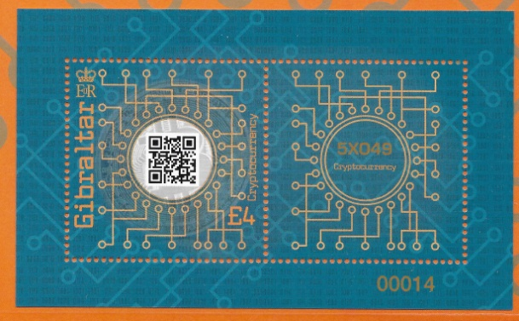
Figure 1: The £4 cryptocurrency postage stamp and se-tenant label.
(Reproduced with the permission of the Royal Gibraltar Post Office.)

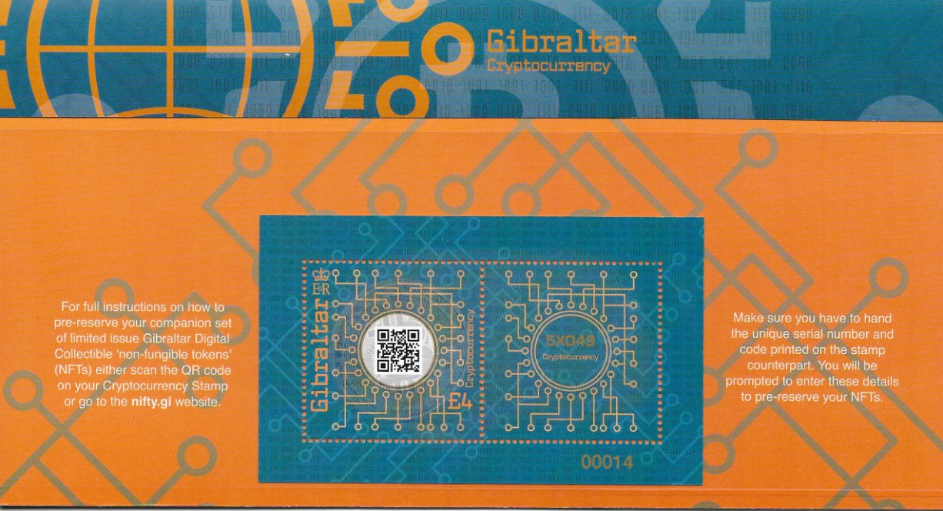
Figure 2: The presentation pack issued by the Royal Gibraltar Post Office for the cryptocurrency stamp issue.
(Reproduced with the permission of the Royal Gibraltar Post Office.)

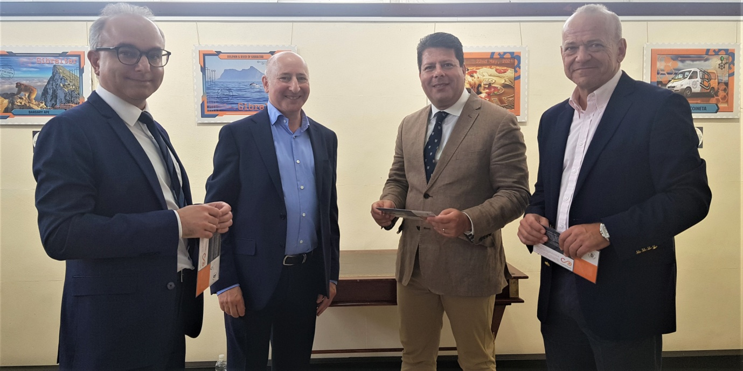
Figure 3: The launch on 16 June 2021.
(Right to left: Hon Albert Isola MP, Chief Minister Hon Fabian Picardo QC MP,
Chairman of Coinsilium, Malcolm Palle, and Hon Vijay Daryanani MP.
(Photo courtesy Ms Alice Mascarenhas.)

