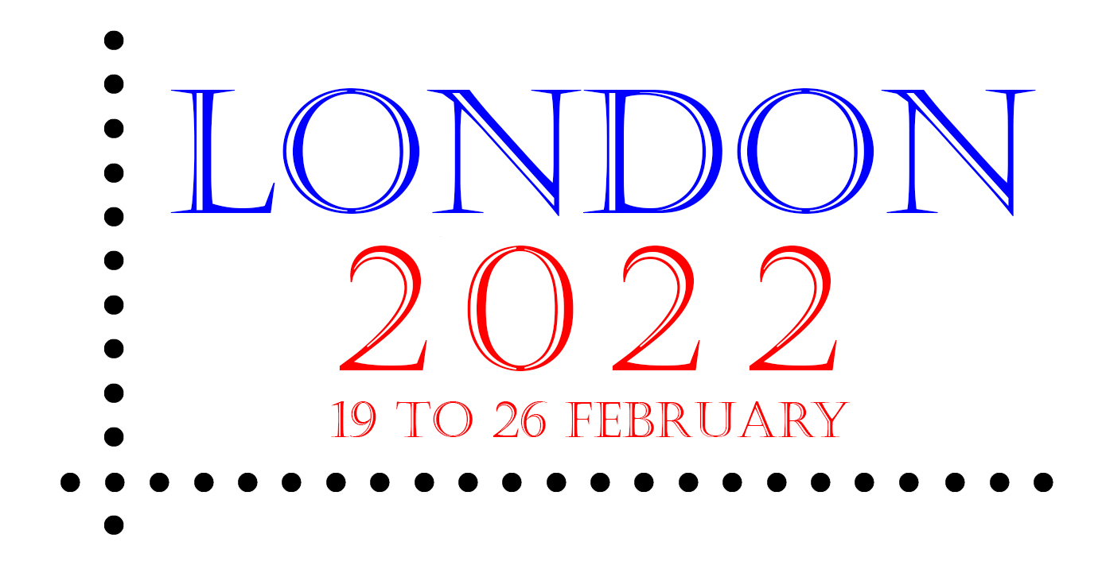

Face-to-face once again

The wait will soon be over for those who want to be able to browse through an unrivalled array of material and chat to dealers from around the world, when London 2022 opens its doors. The international stamp exhibition will take place on 19 to 26 February next year at the Business Design Centre in Islington in London (nearest Underground Station: Angel).

With around 125 booth holders expected, visitors will be greeted by stamp dealers, auctioneers, publishers and postal administrations. Whatever your field of interest, whether it be stamps or postal history, thematics or Cinderellas, stationery or revenues, all collectors are certain to find something of interest. Items that make your collection special, plus literature and accessories, will all be on offer.

Visit london2022.co and search under ‘Bourse’ for details of the booth holders who have already booked.

Understandably, events during the past months have meant some of the original booth holders have had to withdraw. There are a few booths still available, shown in red on the floor plan. These include some very attractive sites on the Village Green and on the Mezzanine level, and a few Gallery Bays. Clicking on the ‘red’ booths provides full details, while another click allows vacant booths to be booked.

(8 July 2021)

