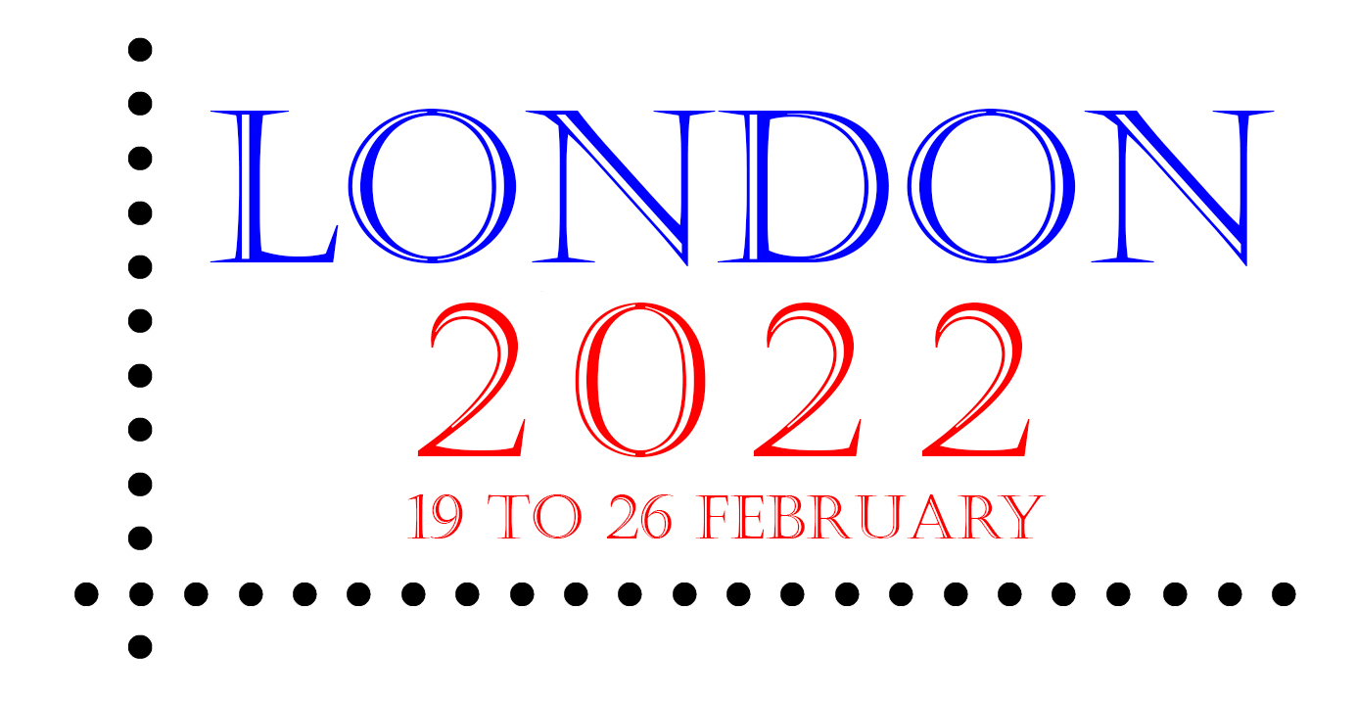

Visiting London 2022

Special arrangements have been made for those visiting London 2022, the international stamp exhibition that will take place on 19 to 26 February next year at the Business Design Centre in Islington in London (nearest Underground Station: Angel).

Visit london2022.co and click on ‘Visits/Hotels’ to find details of the special arrangements that have been made with HotelSmart to secure the best deals at convenient hotels.

By simply clicking for more information, you will be provided with details of selected hotels, plus the opportunity to make further enquiries. HotelSmart can also be found at hotelsmart.co.uk or contacted by telephone on +44(0)1202 533363.

Those who used HotelSmart to make a booking for London 2020 should have had their original booking cancelled, and a fresh booking will need to be made. Please check with HotelSmart for more information.

All the latest news about London 2022 can be found at london2022.co.

(15 July 2021)

