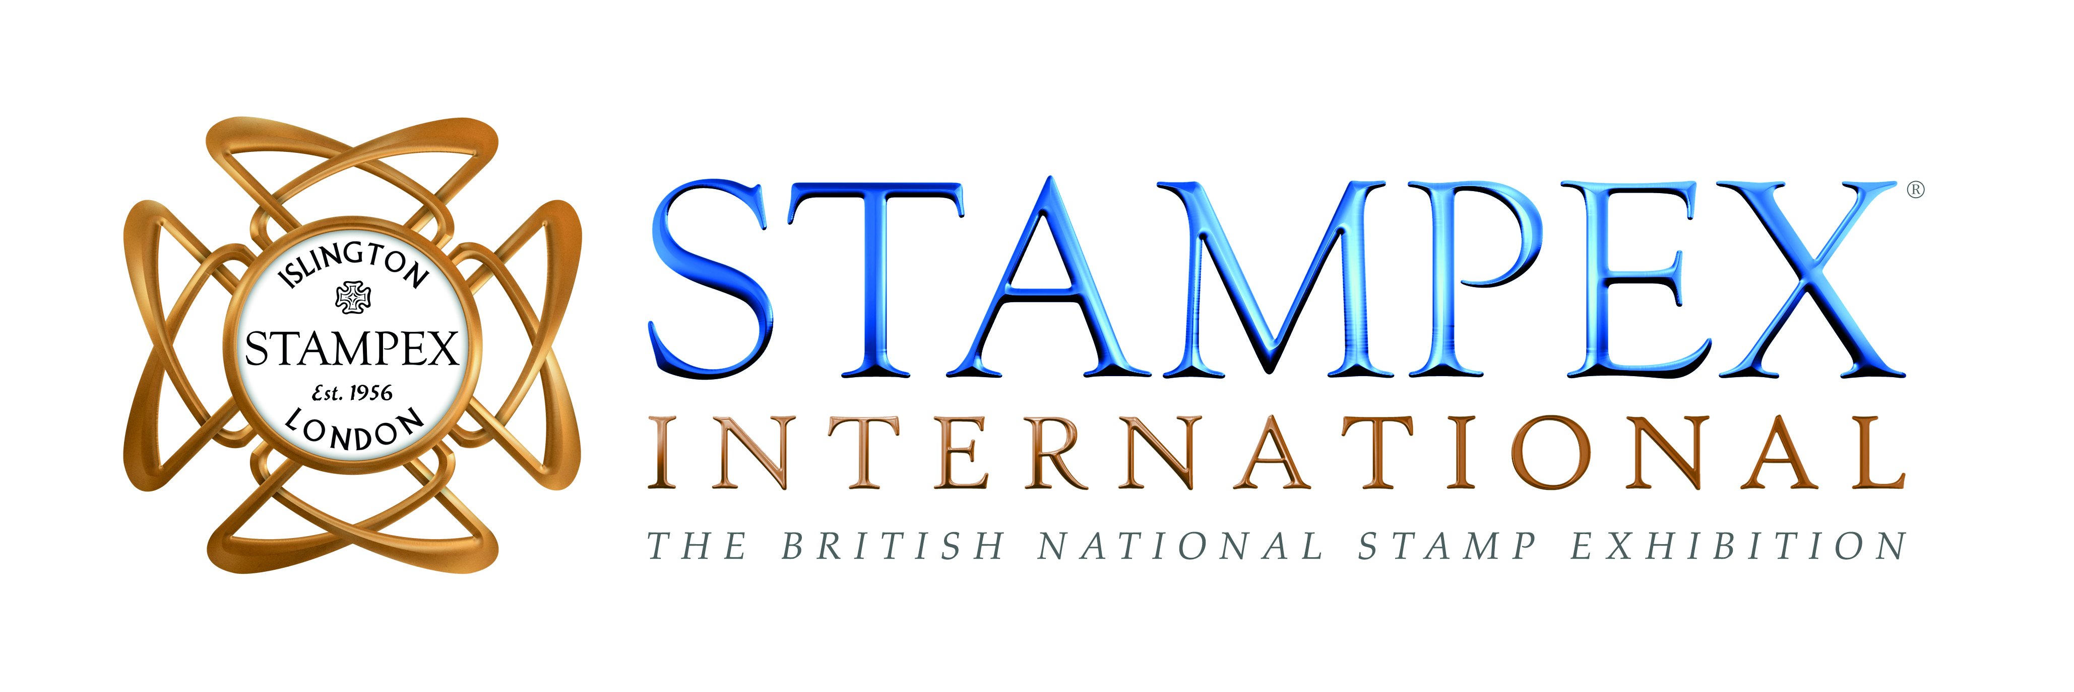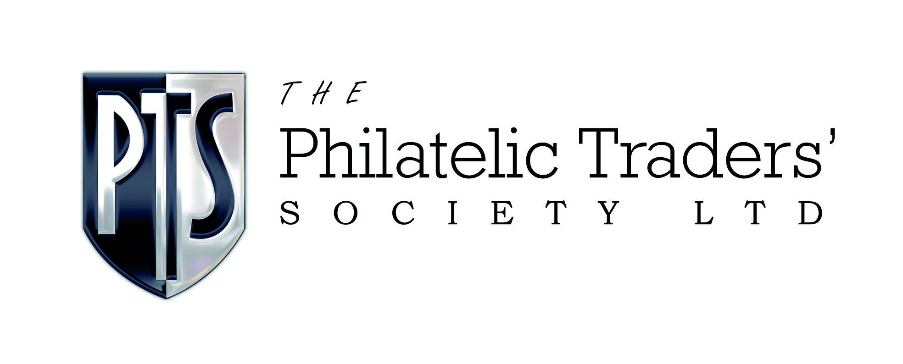

The Philatelic Traders’ Society Announce A NEW Concept Stampex

London July 2021: The Philatelic Traders’ Society, organisers of Stampex , sponsored by Spink, the world's leading auctioneer of stamps, are delighted to announce that Stampex 2021 will be held from 29th September – 2nd October 2021 at the Business Design Centre in London with an exciting new look and feel. All government guidelines relating to COVID-19 will be adhered to and additional safety precautions will be in place to reassure visitors attending this world-class philatelic event.

Since the last physical Stampex in Autumn 2019, and taking learnings from the global success of two Virtual Stampex events, the Philatelic Traders’ Society (PTS) has been working hard behind the scenes to strengthen and reshape the physical show with new ‘zones’ and additional concepts to really bring all aspects of collecting to life. For those who are unable to visit London, the PTS is proud to announce that some parts of the show will be available online, giving collectors all around the world the chance to get involved in Stampex International.

What’s new:

Stands: New Dealers, Auction Houses, Societies and Philatelic Services
All stands at the show are now situated on the Mezzanine and in the Gallery Bays. You’ll find over 70 PTS Members including some of your favourites like Spink, Royal Mail, Stanley Gibbons, BB Stamps, Mark Bloxham, Michael Chipperfield, Thematix, Benstamps, Andrew J Lajer and more. Lots of different activity is taking part at the show Bill Barrell will be hosting Mike Williams on his stand, and David Feldman SA will be presenting the “Imperium” collection of British Guiana. You will also find some new names including Tony Lester Auctions and BEHR.

Amy Smith from Tony Lester Auctions comments
‘I started working with my dad at Tony Lester Auctions just over 2 years ago it has been an exciting rollercoaster of learning. I’m very honoured to have such an experienced mentor and we also have a lot of fun along the way! We haven’t done Stampex previously and I had heard a lot about the show, so we decided to take a stand (48) and we are looking forward to seeing everyone there. It’s a privilege and a joy to have been welcomed so warmly into the amazing world of philately.’

Stampex Talks in the Spink Auditorium
After the success of Stampex Talks at Virtual Stampex, you’ll now find a unique zone for to hear from some leaders within the philatelic community as they chat about their collections, offer insight into the hobby and teach us something new. Watch this space for exciting sessions like ‘Learn how to be an Auctioneer’ and ‘Expertising’. The Auditorium is proudly sponsored by Spink. We are delighted to be partnering with the British Library, The Royal Philatelic Society London, Bill Barrell and Spink as well as others.

Collectors Lounge
At Stampex, you’ll find a dedicated area where you will be able to meet members of The Royal Philatelic Society London and PTS Members, who will be on hand to help answer your questions about collecting. This ‘Collectors Lounge’ area will also be home to exhibiting clinics and more.

Youth Zone
Our Youth Zone will be celebrating Postcrossing’s World Postcard Day. We will also be working with Stamp Active and others to bring this area to life for children and teenagers.

The Delcampe Digital Shopping Zone
Proudly sponsored by Delcampe. If you want to avoid the crowds and browse even more philatelic treasures then head to our new digital zone, which will include an interactive shopping wall, with QR codes direct to your favourite brands.

Museum of Philately
The Museum of Philately is a unique digital platform that captures and preserves award winning collectors, collections and rarities, as well as providing the facility to track provenance and pricing information. This is a rare opportunity to see the Museum brought to life in physical form, and find out more about what they do.

Exclusive Art Exhibition
Spink will be holding a display of work by Ann Carrington. The use of discarded, found and multiples of objects is a fundamental element of Carrington's practice. Mundane objects like knives and forks, barbed wire, pins and paintbrushes come with their own readymade histories and associations which can be unraveled and analyzed if rearranged, distorted or realigned to give them new meaning as sculpture. Ann is inspired by stamps and has created several stamp related pieces. Ann is a world-renowned artist with commissions from Royal Mail, Victoria & Albert Museum, UN, Elton John and many others. In 2012 she designed The Royal Jubilee Banner for the Queen in celebration of her diamond Jubilee. Her work will be displayed on the Spink stand throughout the show.

PTS Collector Handbook 2021 and Show Guide
After the success of the first PTS Collector Handbook in 2020, the PTS will be launching the 2021 Edition at Stampex, available alongside your Show Guide from the new Welcome Desk on arrival at the show.

Stampex Online
As an international society that prides itself on innovation, community and professional expertise, the PTS seeks to make philately accessible to all. Whilst the fullest experience will be at the Business Design Centre in London, the PTS recognises that not everyone will be able or willing to travel this year so some parts of physical Stampex will be available live online during the show. With so much to do, Stampex Online will be available throughout October so you can also catch up on anything you have missed.

Tickets
www.stampexinternational.com/tickets

- Opening Day (Wednesday 29th September 2021): £10.00 per pass which includes your copy of the PTS Collector Handbook and Show Guide
- Day 2, Day 3 and Day 4 (Thursday, Friday, Saturday): FREE ENTRY

- Online tickets are available for £5 per person (exchange rate applied where pounds sterling is not default currency) and allows you exclusive membership to the online elements of the show, including real time access to the live Stampex Talks, exclusive videos and show tours, special offers from PTS Members as well as the online PTS Handbook and Show Guide.

Dates for the diary

- Show reveal: We will be hosting a show reveal live on Facebook with our key partners on 4th September 2021. @ptsandstampex to find out more
- Show dates: 29th September – 2nd October 2021

Watch out for more activity to be confirmed. For further information on the show and to be first to hear the latest news, sign up to our e-newsletter at www.stampexinternational.com/signup

If you would like to book a stand, visit www.thepts.net/bookastand or contact the team to find out more.

For more information, photographer, quotes please email Isobel Klempka | PR & Marketing | Isobel@thepts.net | +44 (0) 7788 793 268

About Spink
Spink is the world's leading auctioneer of stamps, coins, banknotes, medals, bonds & shares, autographs, books and wine. Since its foundation in 1666, the Spink name has become synonymous with tradition, experience and integrity. Holder of royal warrants and numerous records for prices achieved at auction, Spink offers an unparalleled range of services to collectors worldwide. Headquartered in London, with offices in New York, Hong Kong, Singapore and Switzerland, Spink holds over 70 auctions a year. Catalogues can be accessed through the Spink website (www.spink.com) or via the Spink App for iPhone and iPad.

About The Philatelic Traders’ Society
The PTS. The International Society for Philatelic Professionals.
Formed in 1929 by a group of established stamp dealers, The Philatelic Traders’ Society was created to act for and on behalf of its members for the good of philately. With a Code of Ethics and a service for dispute resolution, The Philatelic Traders’ Society is regarded as a reputable organisation within the industry, upholding the values of honesty and integrity. The PTS also organises Stampex and Virtual Stampex – the UK’s leading philatelic exhibition. #lookfortheshield

