NOMINATION  FOR THE FEPA 2024 MEDAL  FOR EXCEPTIONAL PHILATELIC STUDY AND RESEARCH  PRESENTED BY FEPA MEMBER FEDERATION  ____________________________________ | 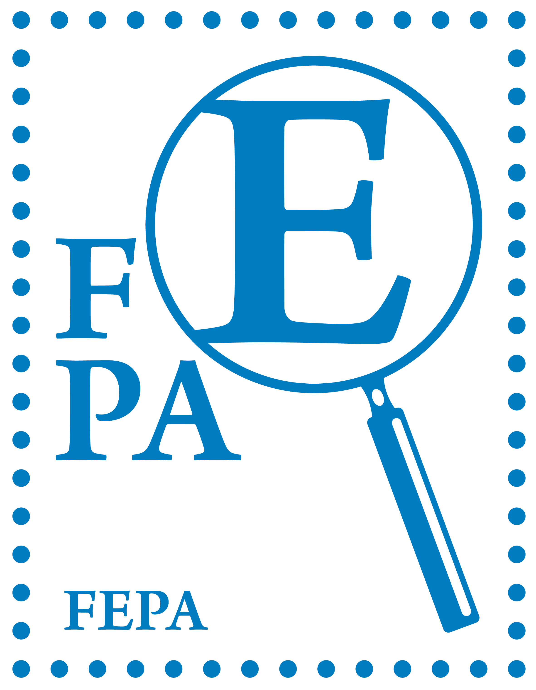
NOMINEE:
OTHER NOMINEE(s) (in case of co-author(s):
TITLE OF THE WORK:
PUBLISHED BY:
PUBLISHING YEAR:
MOTIVATION:
Please concisely summarise the work, describing why it is nominated. As the medal is awarded for study and research, nominations should focus principally on these aspects of the work rather than, for example, the author's distinguished record as an exhibitor or juror.

PTO
BY SUBMITTING THIS FORM, THE FEDERATION ATTESTS THAT IT HAS OBTAINED THE CONSENT OF THE NOMINEE(S) TO PRESENT THIS PROPOSAL.
FORM TO BE FILLED IN ENGLISH AND SENT BY THE FEDERATION’S PRESIDENT TO awards@fepanews.com at the latest by 10 December 2024.
Please attach:
- PHOTO OF THE NOMINEE(S) (jpeg format, 300 dpi, colour)
- IMAGE OF THE COVER OF THE BOOK(S) (jpeg format, 300 dpi, colour)

A PDF FILE WITH THE WHOLE WORK will be sent to gmorolli@gmail.com using WeTransfer or a similar platform. Such files will be made available to the FEPA Board members and the special panel members appointed to assist the Board in awarding the medal. The FEPA Board declares that the pdf file shall be used only for evaluation purposes related to the FEPA medal for research.

A PAPER COPY OF THE WORK is welcome as additional support for the Board’s final decision. The shipping address will be circulated after the Board meeting venue is decided.

NO OTHER ITEMS ARE NECESSARY.

